**Module 2 - Connect to Data:**

**Connect to data**

With Power BI Desktop installed, you're ready to connect to the ever-expanding world of data. To see the many types of data sources available, select **Get Data** > **More** in the Power BI Desktop **Home** tab, and in the **Get Data** window, scroll through the list of **All** data sources. In this quick tour, you connect to a couple of different **Web** data sources.

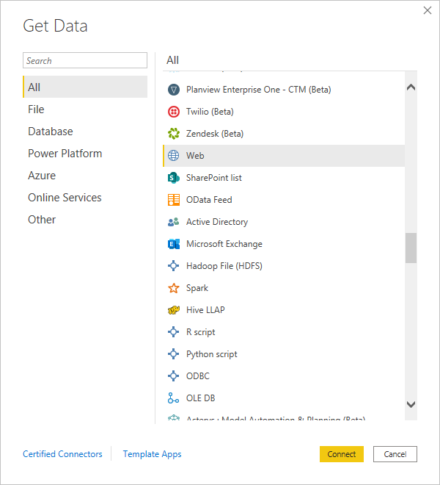

Imagine you're a data analyst working for a sunglasses retailer. You want to help your client target sunglasses sales where the sun shines most frequently. The Bankrate.com [Best and worst states for retirement](https://www.bankrate.com/retirement/best-and-worst-states-for-retirement/) page has interesting data on this subject.

On the Power BI Desktop **Home** tab, select **Get Data** > **Web** to connect to a web data source.

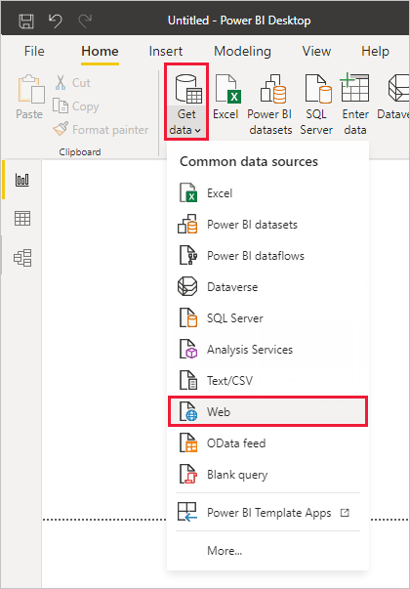

In the **From Web** dialog box, paste the address *https://www.bankrate.com/retirement/best-and-worst-states-for-retirement/* into the **URL** field, and select **OK**.

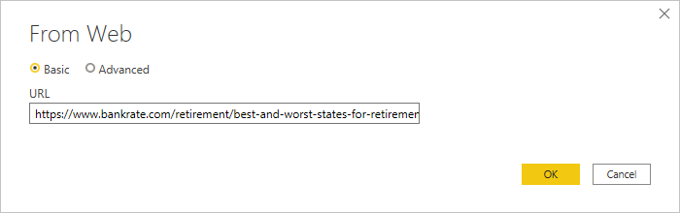

If prompted, on the **Access Web Content** screen, select **Connect** to use anonymous access.

The query functionality of Power BI Desktop goes to work and contacts the web resource. The **Navigator** window returns what it found on the web page, in this case an HTML table called **Ranking of best and worst states for retirement**, and five other suggested tables. You're interested in the HTML table, so select it to see a preview.

At this point you can select **Load** to load the table, or **Transform data** to make changes in the table before you load it.

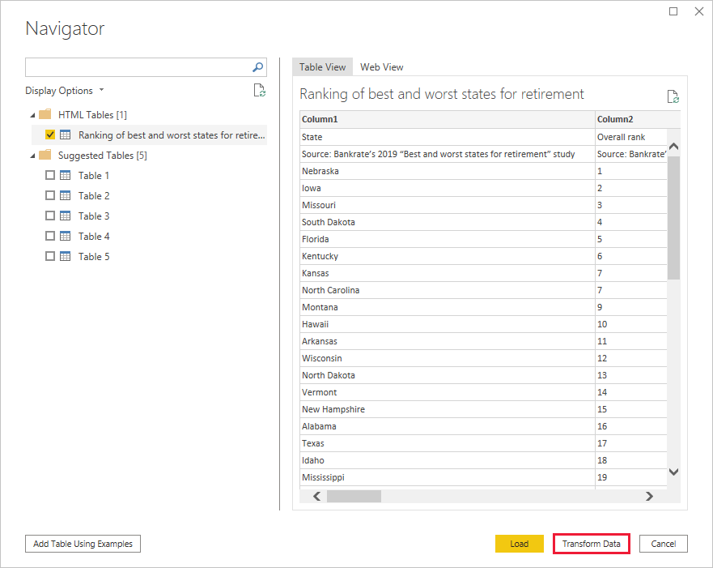

When you select **Transform data**, Power Query Editor launches, with a representative view of the table. The **Query Settings** pane is on the right, or you can always show it by selecting **Query Settings** on the **View** tab of Power Query Editor.

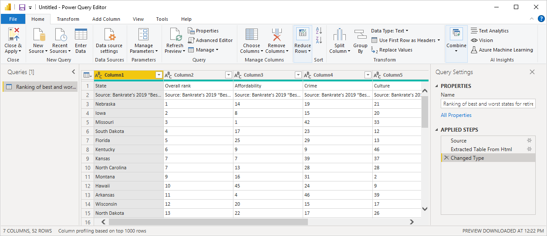

For more information about connecting to data, see [Connect to data in Power BI Desktop](https://docs.microsoft.com/en-us/power-bi/connect-data/desktop-connect-to-data).